**Final Report**

**Set_2_Q_1**

For the two port network shown in figure below, obtain the Z-parameters, ABCD (transmission) parameters and h (hybrid) parameters. Cross check your results obtained from simulation against hand calculations. What should be the value of load resistance connected at Port-2 for maximum power transfer when a voltage source of 25V is connected at Port-1.

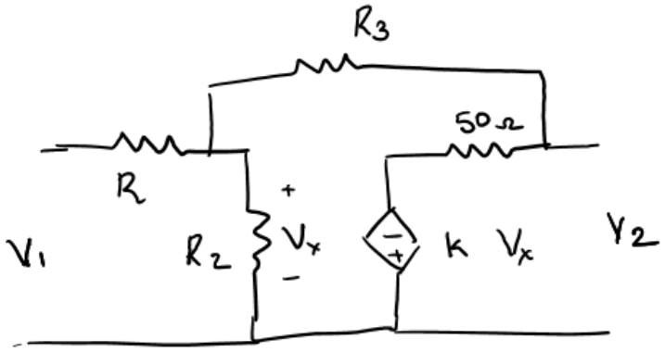

|  |  |  |
| --- | --- | --- |
| S.No. | Resistor Name | Value in kΩ |
| 1. | R1 | (Last digit of your ID + 3) multiplied by your tut section no. |
| 2. | R2 | Product of last two digits of your ID + tut section no. |
| 3. | R3 | (Sum of last three digits of your ID % 8)*Tut Section no. |
| 4. | K | Last two digits of your year of admission – Tut section number |

**Suggestion – Keep the values of resistor as small. For example, keep 10 ohm instead of 10k Ohm. This is because, the values of different parameters only stabilize for a larger value of V_in. Smaller the value of resistor, flatter response do we get. Also, it makes it easier for applying KVL/KCL( during hand calculations) as the values can be approximated to whole numbers.**

**To solve, follow the following steps in respective order**

* Assume I_out = 0, we can get Z11, Z21, A, C.
* Assume I_in =0, we can get Z12, Z22, h12, h22,D
* Assume V_out = 0, we can get h11, h21, B

**I used .step param method for any external voltage source that I used and plotted the graph for getting various values.**

1. **I_out = 0**

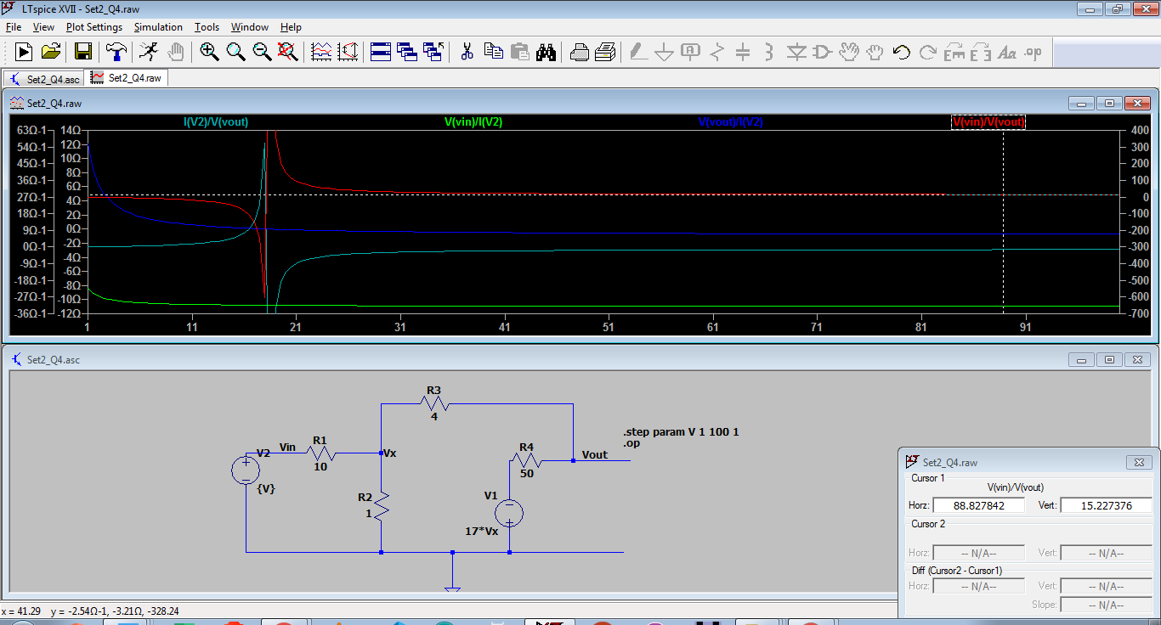

Z11 = -10.943738Ohm

Z21 = -718.68835mOhm

A = 15.227376

C = -1.3914237Ohm-1

1. **I_in = 0**

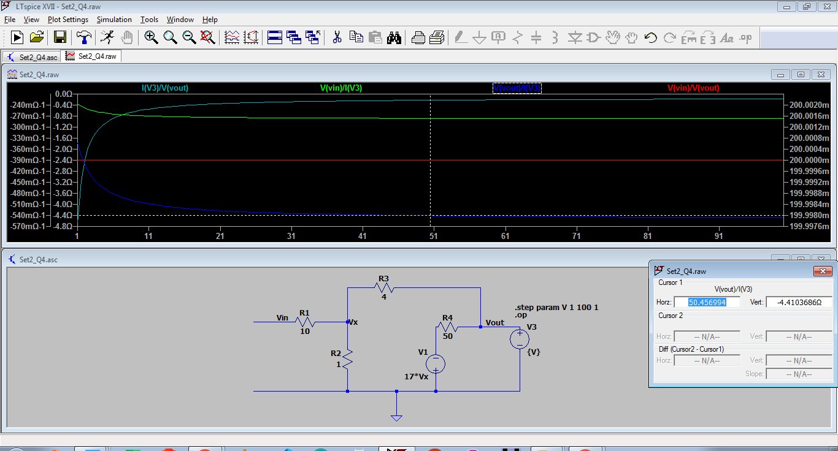

Z12 = -893.45379mOhm

Z22 = -4.4672689Ohm

H12 = 0.2

H22 = -0.223Ohm-1

D = 624.22m

1. **V_out = 0**

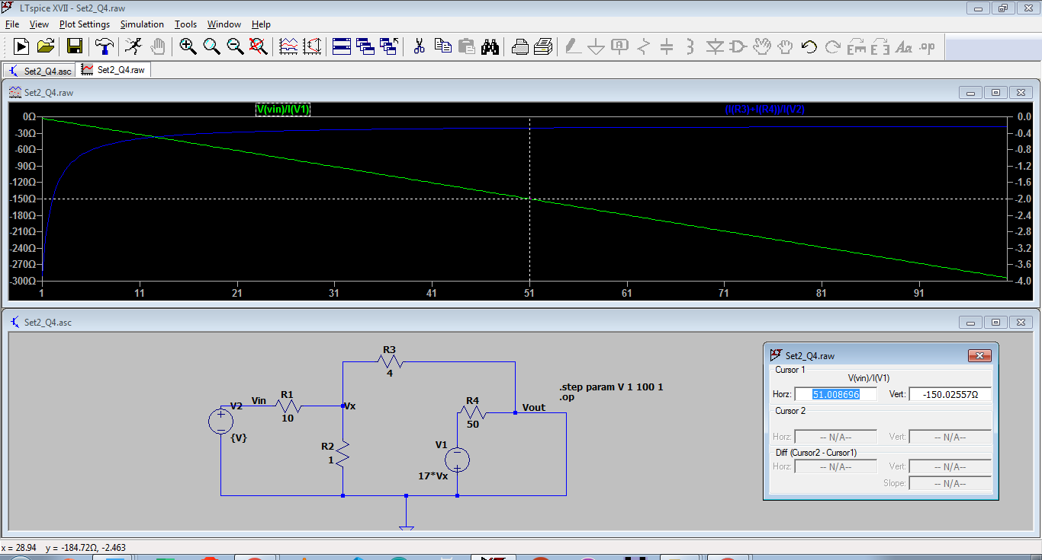

H11 = 2.7555*Vin

H21 = -244.9521m

B = 11.2903*Vin

**For maximum Power Transfer, I used the following schematic**

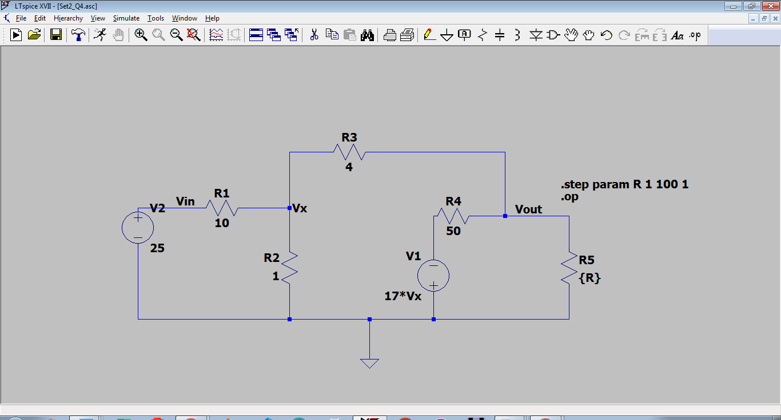

**The result plot was as follows, which showed that the Load Resistance should be 4.3404908 Ohm**

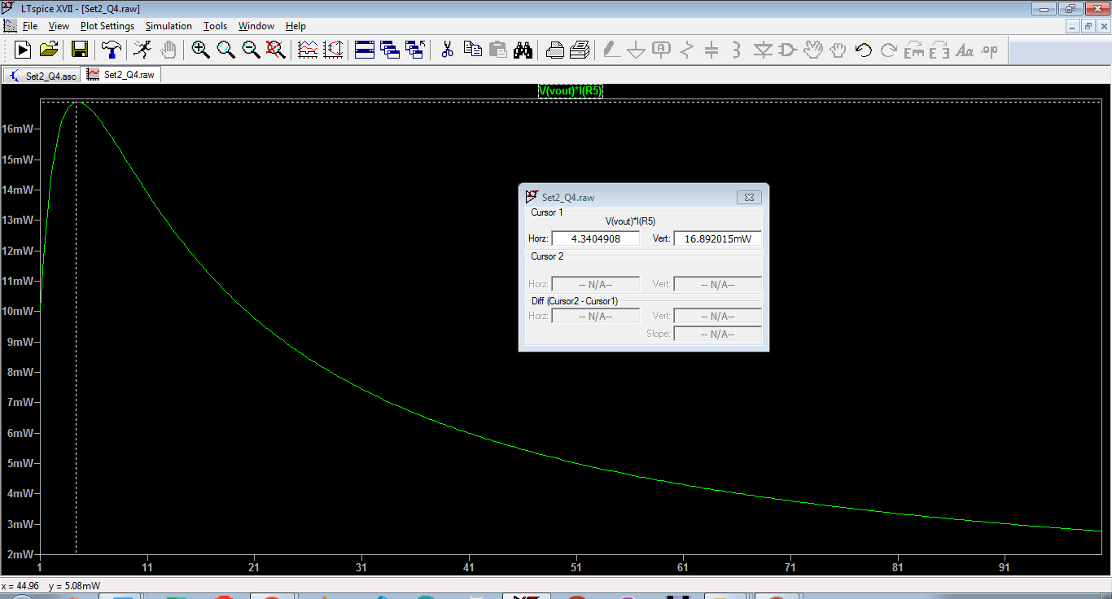

**Set_2_Q_4**

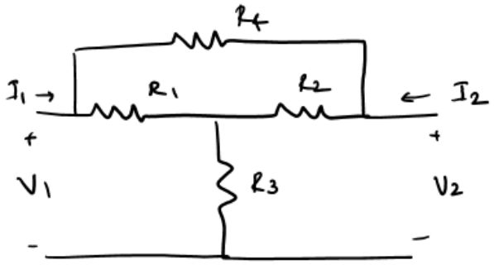

For the two-port network shown in figure below, obtain the Z-parameters, ABCD (transmission) parameters and h (hybrid) parameters. Cross check your results obtained from simulation against hand calculations. What is the gain if a voltage source has a resistance 5k and the load resistance is 1kohm.

|  |  |  |
| --- | --- | --- |
| S.No. | Resistor Name | Value in kΩ |
| 1. | R1 | (Last digit of your ID + 3) multiplied by your tut section no. |
| 2. | R2 | Product of last two digits of your ID + tut section no. |
| 3. | R3 | (Sum of last three digits of your ID % 8)*Tut Section no. |
| 4. | R4 | Last two digits of your year of admission – Tut section number |

For me, R1 = 10, R2 = 1, R3 = 4, R4 = 17

**Solution – Follow the following steps in respective order**

* Assume I_out = 0, we can get Z11, Z21, A, C.
* Assume I_in =0, we can get Z12, Z22, h12, h22,D
* Assume V_out = 0, we can get h11, h21, B

The problem is to be solved using 2-port using 2 methods :

1. Using an assumed value of external DC voltage and applying .op command. This can be used to do the hand calculations as shown below :-

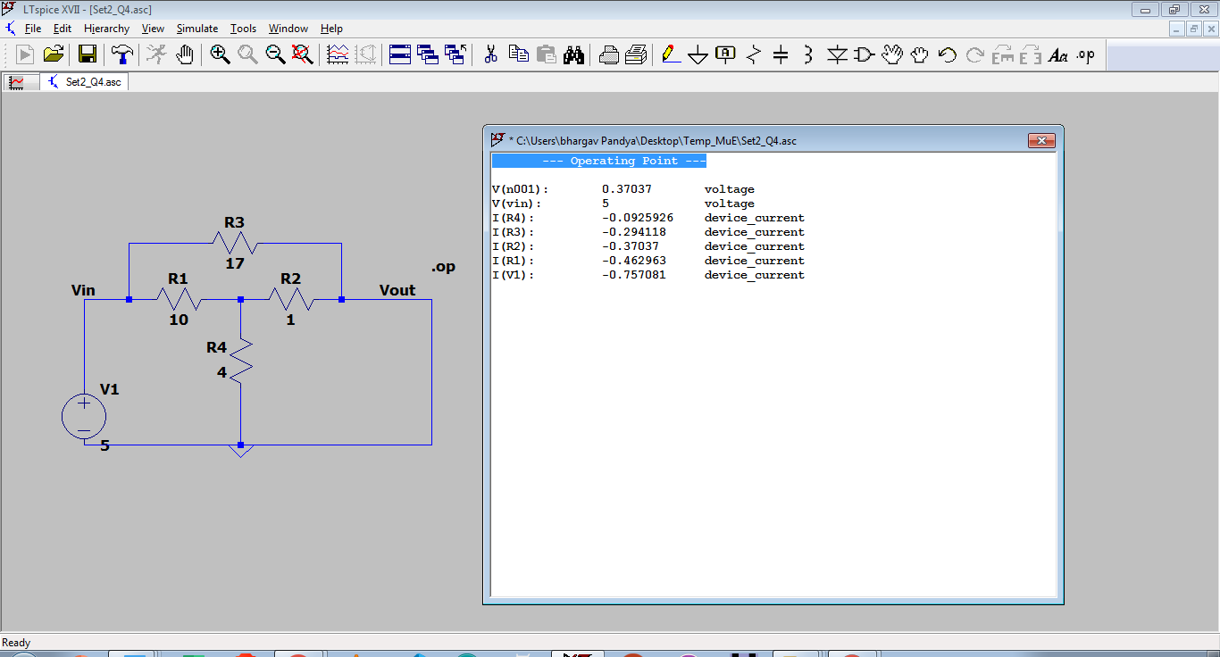

1. Using a parametric sweep for the external DC voltage that has been applied and finding the ratio in the graph itself, as shown below :
   1. **Assuming I_out = 0**

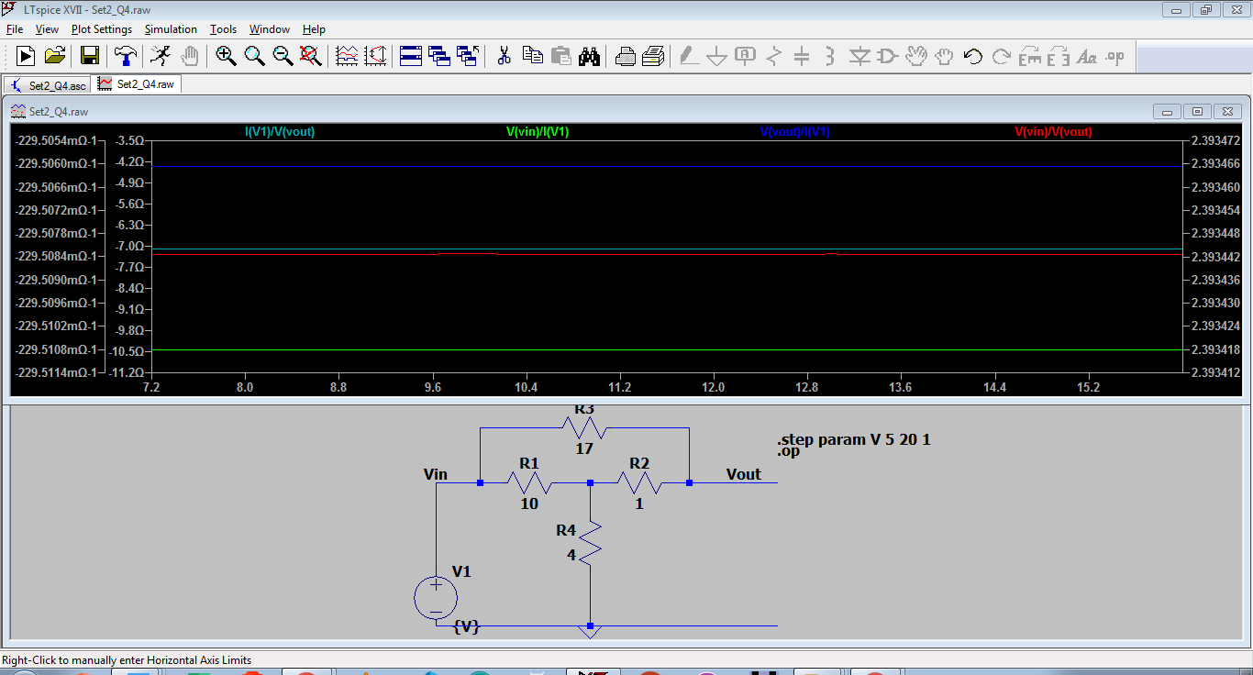

C = -229.5082mOhm-1

Z11 = -10.428571Ohm

Z21 = -4.3571428Ohm

A = 2.3934426

* 1. **Assuming I_in = 0**

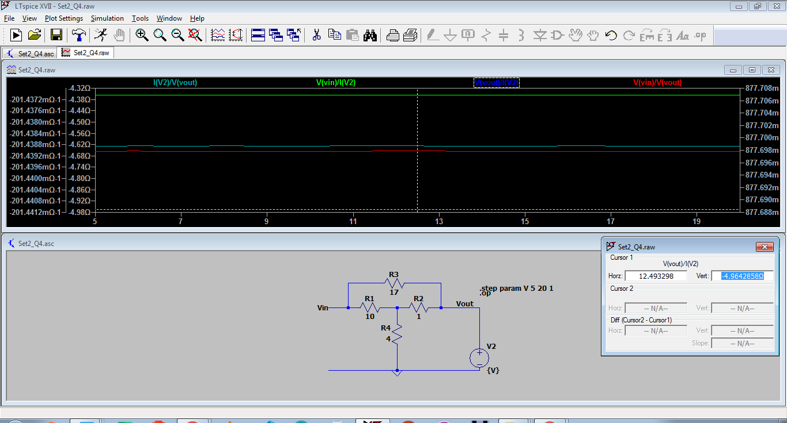

Z12 = -4.357143Ohm

Z22 = -4.9642858Ohm

H11 = 877.69787m

H22 = -201.43885mOhm-1

D = C/H22 = 1.1393

* 1. **Assuming V_out = 0**

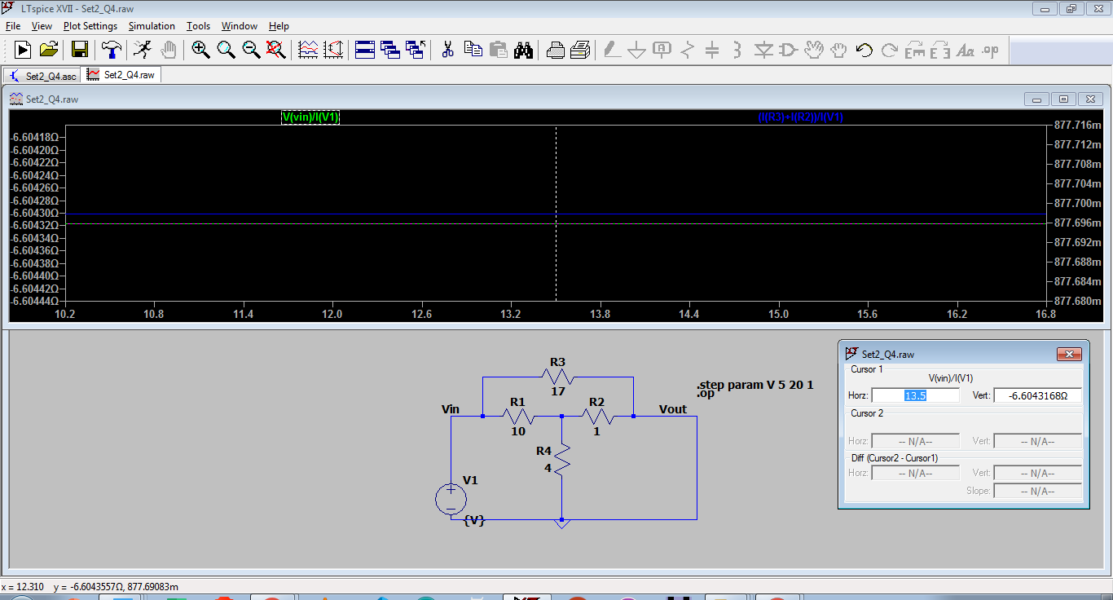

H11 = -6.6043168Ohm

H21 = 877.69788m

B = -H11/H21 = 7.53021

The Voltage gain for the given condition is 0.10082645

The current gain for the given condition is - 0.73053894

**Set_2_Q_1**

For the rectifier circuit shown below, Plot the transient analysis for a sinusoidal input signal of frequency 10V amplitude, 50Hz frequency

Find the ripple factor and efficiency from the output waveform.

Diode model to be used: 1SR154-400

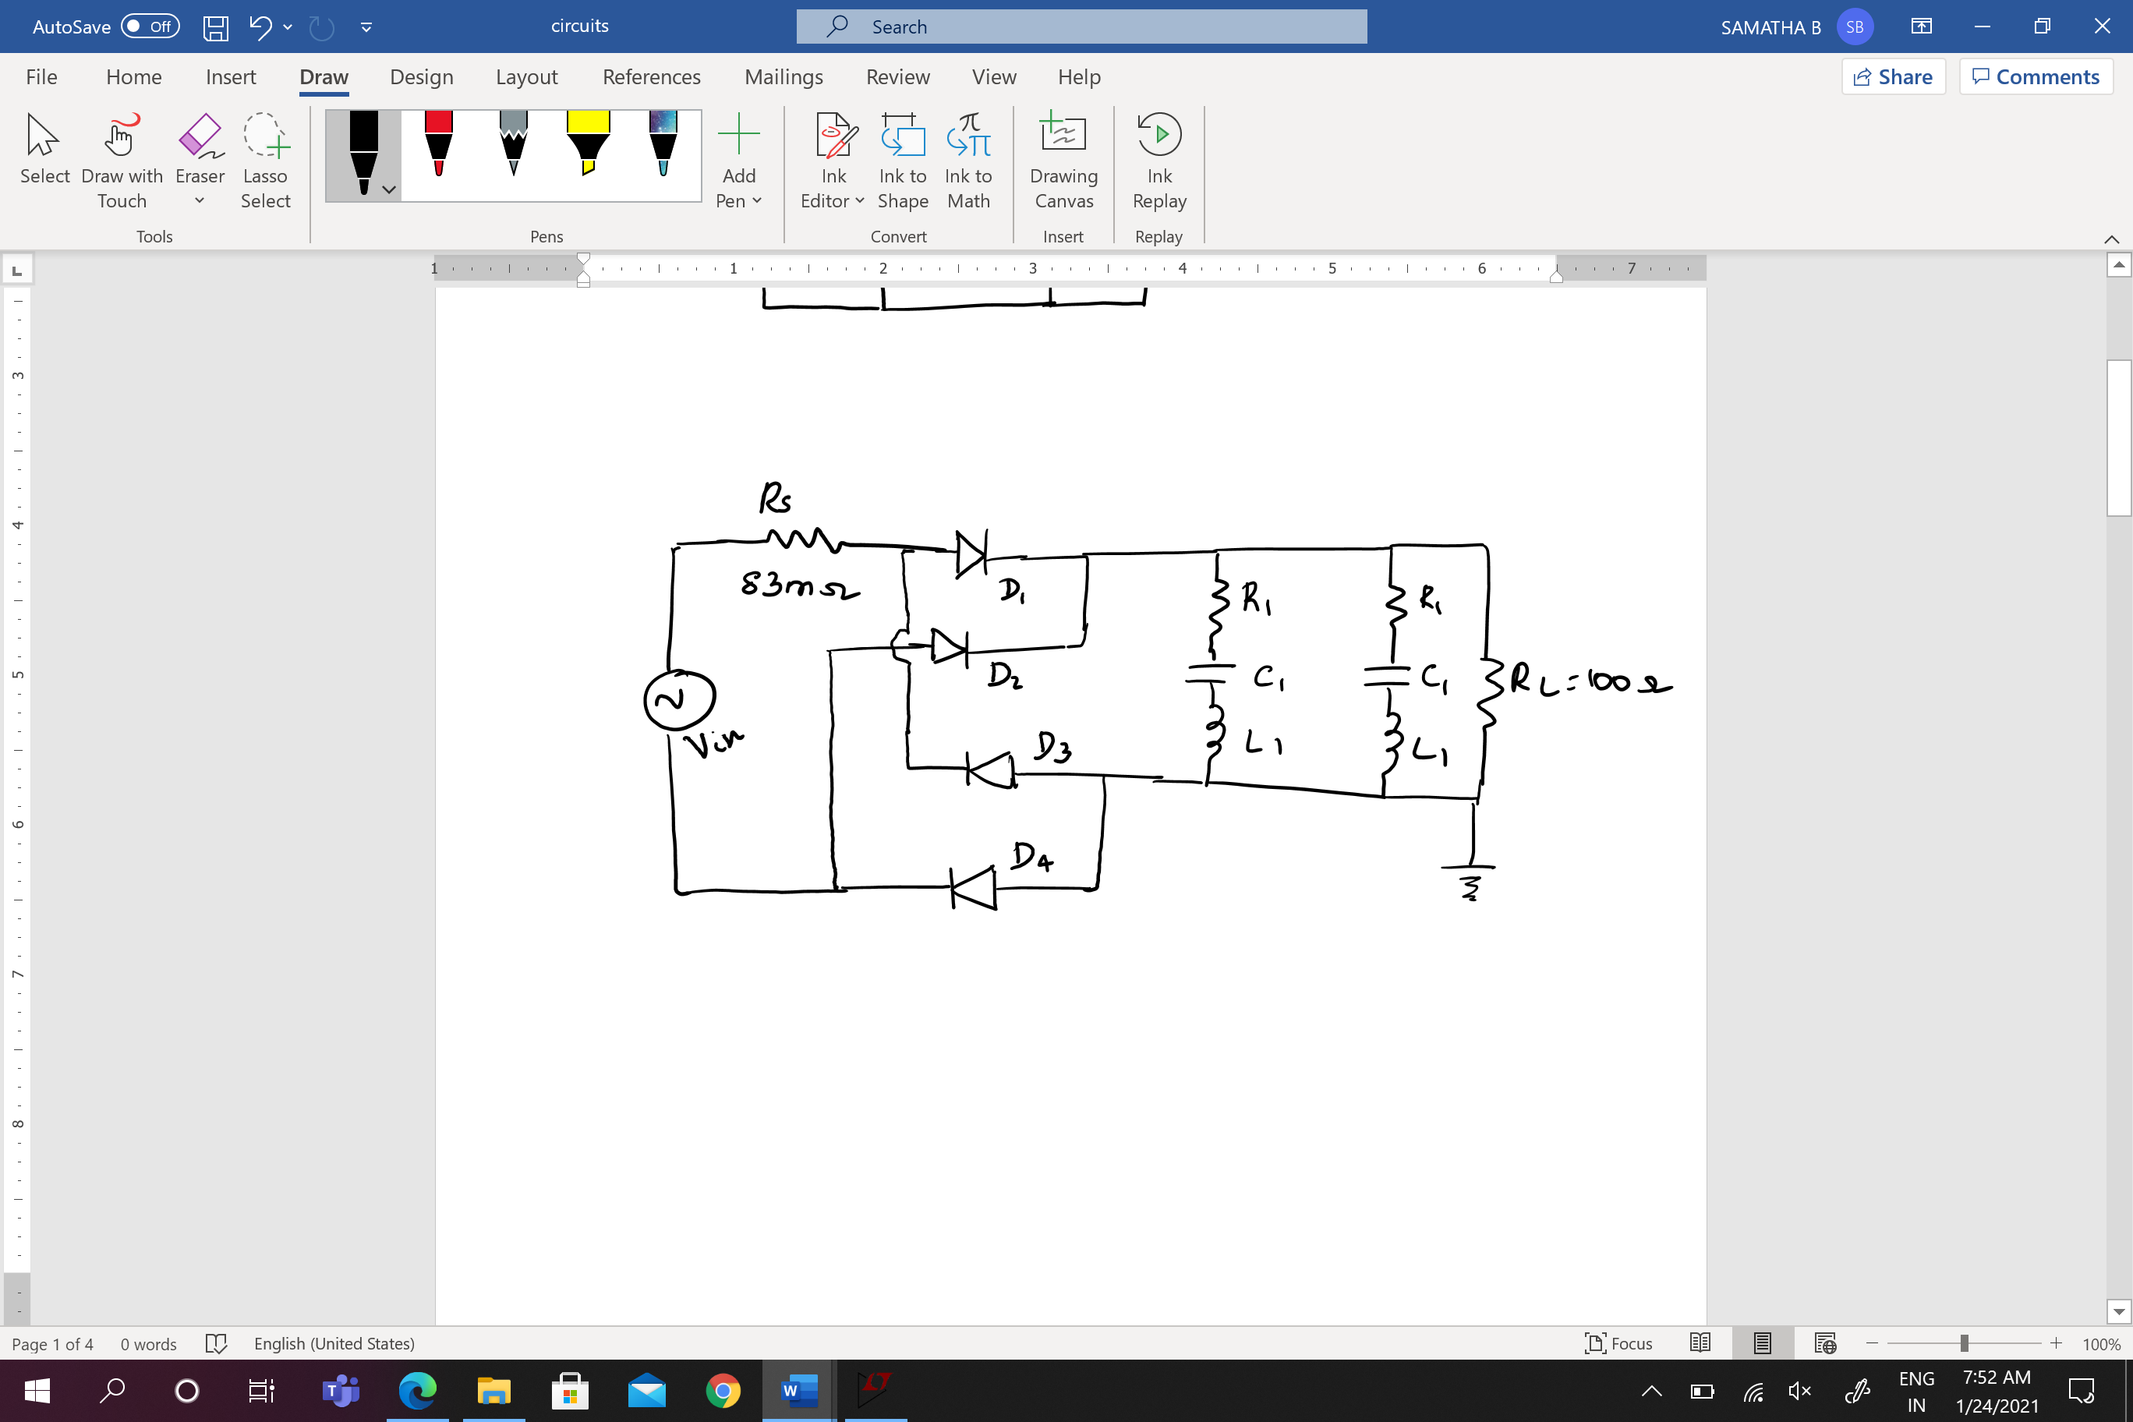

|  |  |  |
| --- | --- | --- |
| S.No. | Resistor Name | Value in kΩ |
| 1. | R1 (mohm) | (Last digit of your ID + 3) multiplied by your tut section no. |
| 3. | C1 (uF) | (Last 4 digits of your ID *Tut Section no. |
| 4. | L1 (nH) | Last two digits of your year of admission – Tut section number |

**For me, R = 10, C = 507, L = 17**

**Final Schematic :**

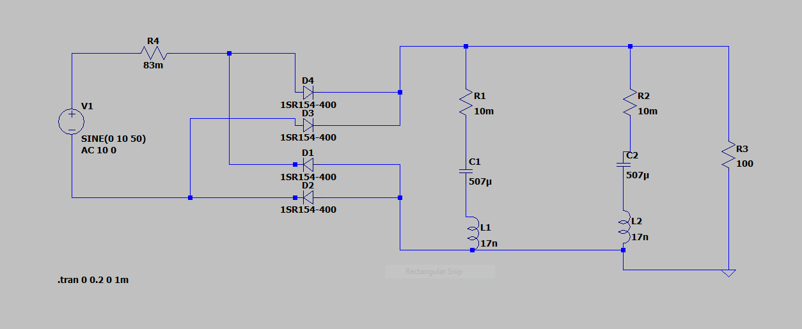

**Suggestion – Modify the capacitance value to keep it less than 2000uF as after this point, it takes more than one cycle to get to peak voltage and this might make the calculations more complex.**

**Solution –**  Use the .trans method to perform transient analysis and check the output waveform at different time values.

The Output graph is as follows

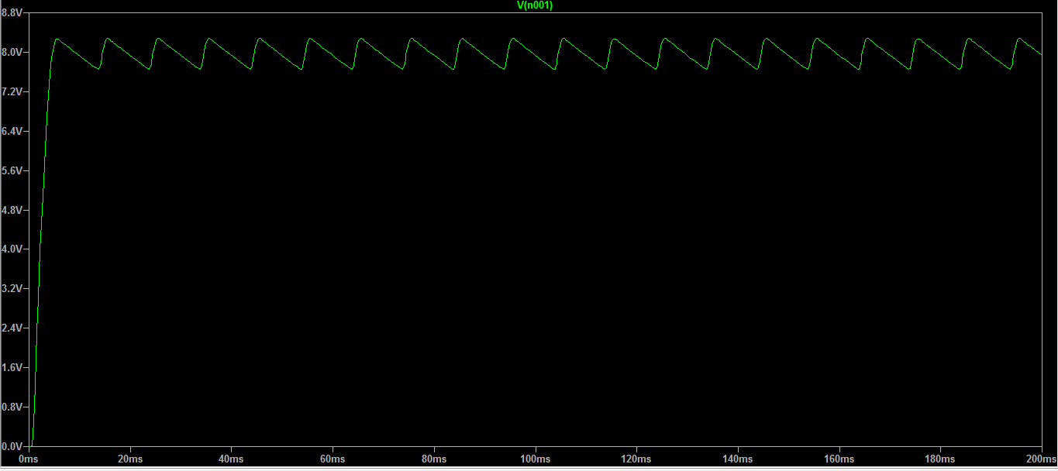

**V (p-p) = 0.62125**

**V (dc) = 7.96198665**

**Ripple factor = 7.802 %**

For power efficiency, I plotted graph using same method but changed the traces.

Power efficiency obtained = 70%

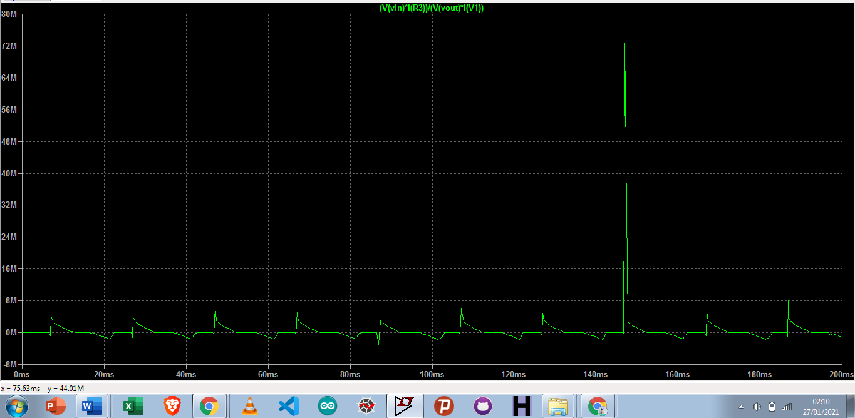

**We can see that the power offshoot at a certain value of time.**

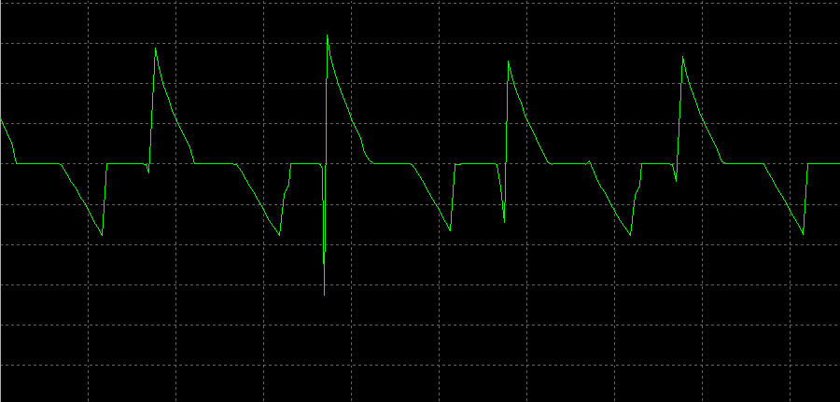

**Set_1_Q_3**

For the MOSFET circuit below, input is sinusoidal signal of amplitude 1V and frequency 50Hz. Find, the DC operating point, Plot the frequency response and Plot the input, output and transfer characteristics and find out the small signal equivalent.

Use MOSFET 180nm Library file provided.

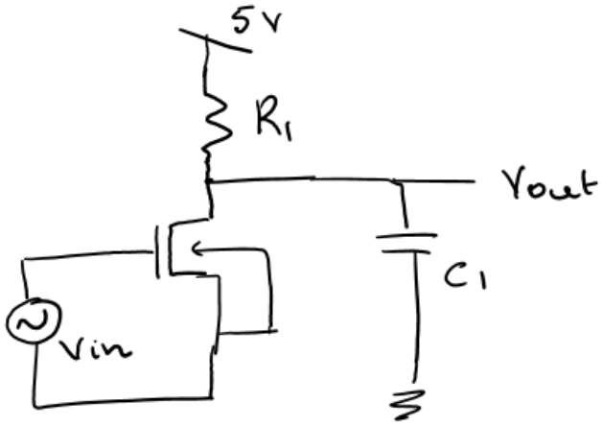

|  |  |  |
| --- | --- | --- |
| S.No. | Resistor Name | Value in kΩ |
| 1. | R1 (kohms) | (Last digit of your ID + 3) |
| 2. | C1 (uF) | (Last digits of your ID + Tut Section no. |

**For me , R1 = 10k, C1 = 8uF**

**Suggestion – The Capacitor value is very large and hence, the biasing curve is not very sharp. Also the 3-dB bandwidth gets very short. Hence, keep smaller capacitance ( for example, make the caps to nF)**

**Solution –**

1. **DC Biasing point**

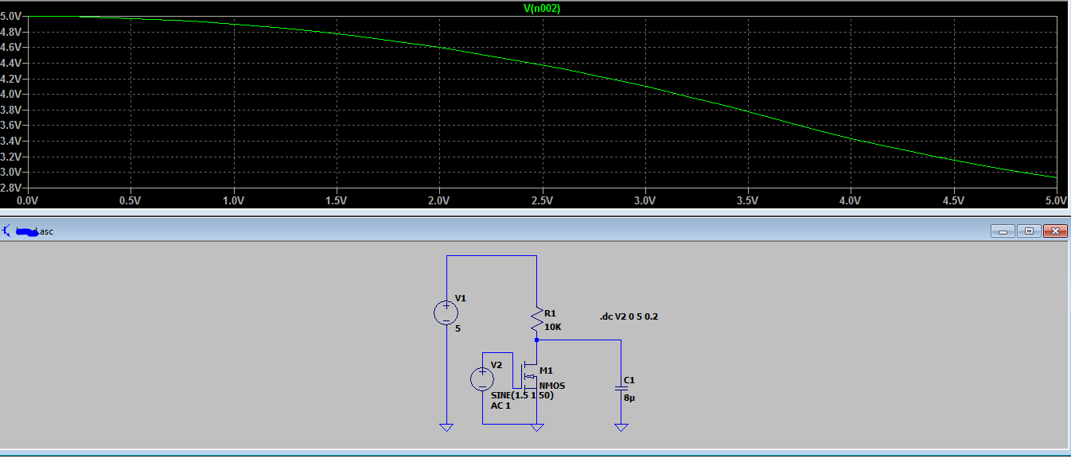

The biasing point obtained is 3 V

1. **Frequency Response**

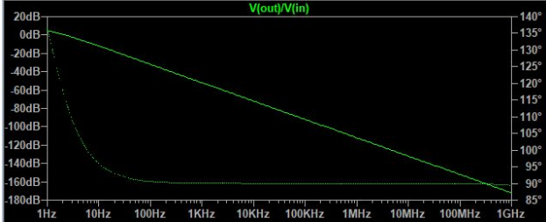

1. **Output Characteristics**

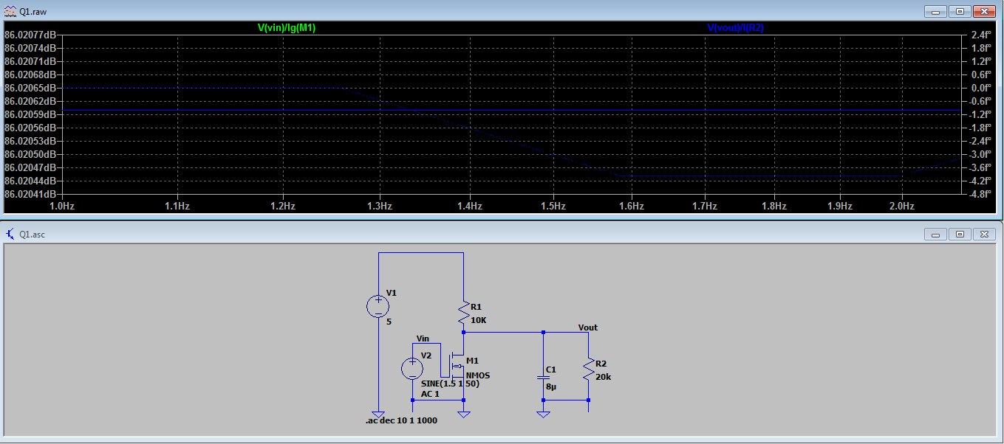

1. **Transfer Characteristics**

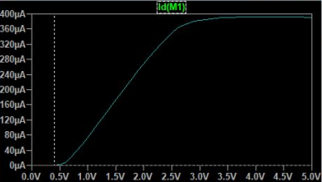

This is the curve for I_inp vs Vout curve.

**Set_1_Q_1**

A schematic of common emitter amplifier (CE) is shown in the figure below. Obtain the DC Operating point, plot the Bode plot for voltage gain (AV) and current gain (AI). Also observe the output waveform for a 1KHz 10mV sine wave as excitation. Also calculate the input impedance (Rin) and output impedance (Rout) of the amplifier.

**a.** What is the impact of R2 on AV, AI, Rin and Rout?

**b.** What is the impact of RE on AV, AI, Rin and Rout?

**c.** What is the impact of Bias voltage VEB on AV, AI, Rin and Rout?

**d.** Design the circuit to achieve the target specifications (as per the table) to be achieved by choosing proper values for Resistors and Bias Voltage.

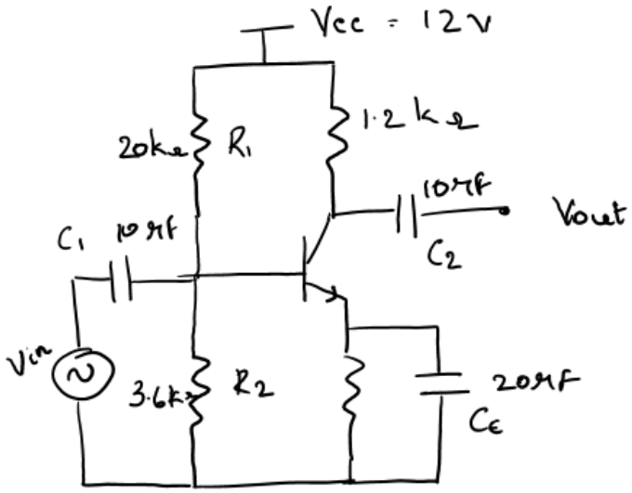

|  |  |  |
| --- | --- | --- |
| Sl.No. | Specification | Value in kΩ |
| 1. | Input Resistance in kΩ | Last digit of your ID + Tut section number. |
| 2. | Voltage gain in dB | Last two digits of your year of admission + Tut Section number |
| 3. | 3 dB Band width in kHz | (Sum of last four digits in your ID % 12) * Tut section number. |
| 4. | BJT Model to be used | BC107A |

**Assuming that for stability, the DC Bias point or Vce = VCC/2 = 6 V**

**Issues – 3-dB Bandwidth is not possible for this range of values.**

**Schematic obtained -** 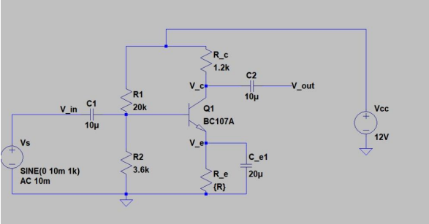

**Using .step param method, we get the following curve**

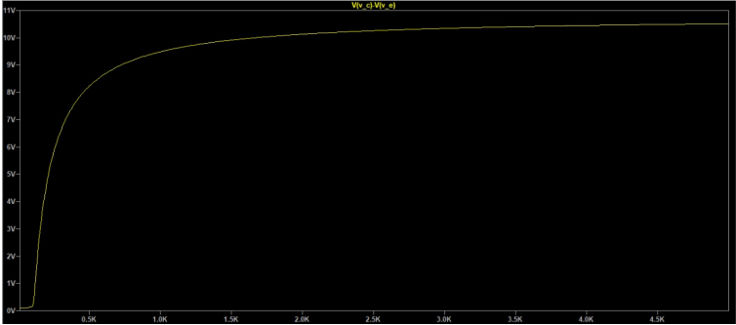 **Henceforth, the value for R_e = 250 Ohms**

**Voltage Gain**

Max gain obtained was 45 dB

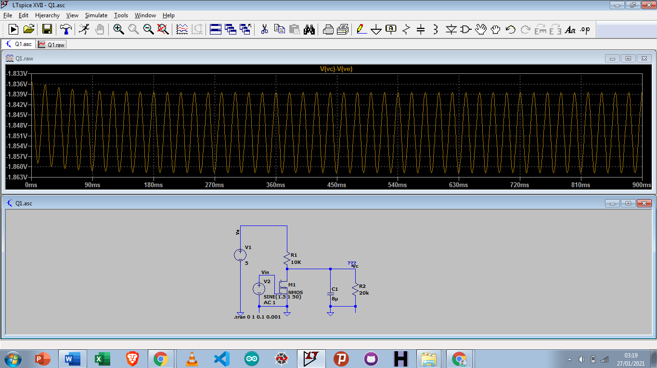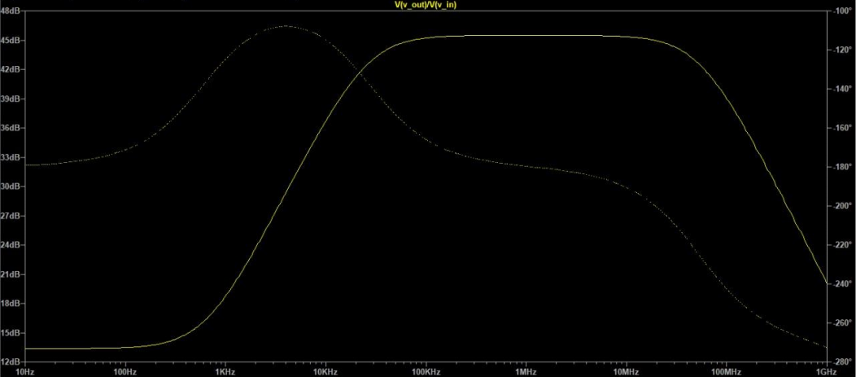

**Current Gain Obtained –**

Peak gain is 43.6dB.

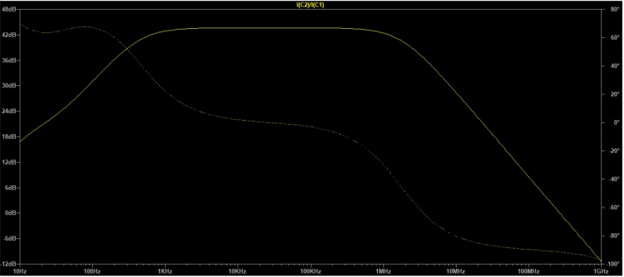

**Schematic used for the output waveform for 10mv,100kHz Input-**

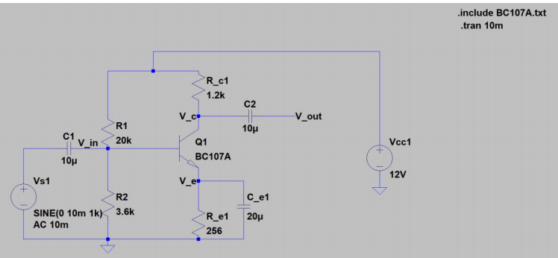

The output waveform obtained is as follows

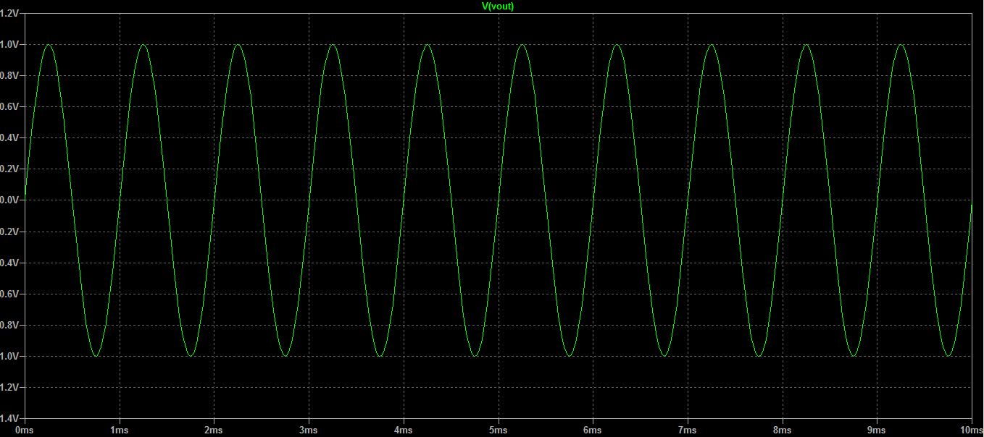

**Finally, for getting the Rin and Rout, I used the .list method in AC analysis to get the values.**

Rin for the given circuit came out to be 1.4k Ohms.

Rout is coming out to be 1.2k Ohms